Applecross Senior High School

Semester One Examination, 2017

Question/Answer booklet

MATHEMATICS

SOLUTIONS
SPECIALIST
UNIT 1

Section Two:

Calculator-assumed

Student Number: In figures

In words

Your name

Time allowed for this section
Reading time before commencing work: ten minutes
Working time: one hundred minutes

Materials required/recommended for this section
To be provided by the supervisor
This Question/Answer booklet
Formula sheet (retained from Section One)

To be provided by the candidate
Standard items: pens (blue/black preferred), pencils (including coloured), sharpener, correction fluid/tape, eraser, ruler, highlighters

Special items: drawing instruments, templates, notes on two unfolded sheets of A4 paper, and up to three calculators approved for use in this examination

Important note to candidates
No other items may be taken into the examination room. It is your responsibility to ensure that you do not have any unauthorised material. If you have any unauthorised material with you, hand it to the supervisor before reading any further.

Structure of this paper

Section | Number of questions available | Number of questions to be answered | Working  time (minutes) | Marks available | Percentage of examination
Section One:  Calculator-free | 6 | 6 | 50 | 52 | 35
Section Two:  Calculator-assumed | 12 | 12 | 100 | 96 | 65
 |  |  |  | Total | 100

Instructions to candidates

1. The rules for the conduct of examinations are detailed in the school handbook. Sitting this examination implies that you agree to abide by these rules.

2. Write your answers in this Question/Answer booklet.

3. You must be careful to confine your response to the specific question asked and to follow any instructions that are specified to a particular question.

4. Additional working space pages at the end of this Question/Answer booklet are for planning or continuing an answer. If you use these pages, indicate at the original answer, the page number it is planned/continued on and write the question number being planned/continued on the additional working space page.

5. Show all your working clearly. Your working should be in sufficient detail to allow your answers to be checked readily and for marks to be awarded for reasoning. Incorrect answers given without supporting reasoning cannot be allocated any marks. For any question or part question worth more than two marks, valid working or justification is required to receive full marks. If you repeat any question, ensure that you cancel the answer you do not wish to have marked.

6. It is recommended that you do not use pencil, except in diagrams.

7. The Formula sheet is not to be handed in with your Question/Answer booklet.

Section Two: Calculator-assumed 65% (96 Marks)
This section has twelve (12) questions. Answer all questions. Write your answers in the spaces provided.

Working time: 100 minutes.

Question 7 (6 marks)
A music playlist contains nine different tracks, including one called First Night and another called Last Night. Each track is three minutes long.

(a) A shuffle feature randomly arranges the nine tracks. Determine the number of all possible arrangements that

(i) start with First Night. (1 mark)
Solution
$$1×8!=40320 \text{ways}$$

Specific behaviours
states number

(ii) start with First Night and end with Last Night. (1 mark)
Solution
$$1×7!×1=5040 \text{ways}$$

Specific behaviours
states number

(iii) start with First Night or end with Last Night. (2 marks)
Solution
$$40320+40320-5040=75600$$

Specific behaviours
uses inclusion-exclusion principle
states correct number

(b) Determine the number of selections of different tracks from the playlist that do not include First Night and Last Night and have a total playtime of 15 minutes. (2 marks)
Solution
$$15÷3=5 \text{tracks}$$
$$^{7}C_{5}=21 \text{selections}$$

Specific behaviours
calculates number of tracks
states number of selections

Question 8 (5 marks)
In the diagram below, $AD$ and $BE$ are diameters of the circle with centre $O$, $C$ lies on the circumference and $∠COD=28°$.

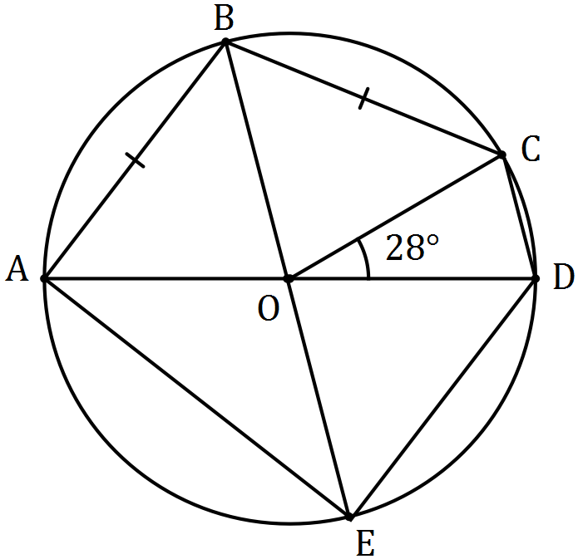

Determine the sizes of the following angles.

(a) $∠AOB$. (2 marks)
Solution
$$∠AOB=∠BOC \\ ∠AOB=\frac{180-28}{2}=76°$$

Specific behaviours
indicates congruent angles
calculates angle

(b) $∠AEB$. (1 mark)
Solution
$$∠AEB=\frac{∠AOB}{2}=\frac{76}{2}=38°$$

Specific behaviours
states angle

(c) $∠ADE$. (2 marks)
Solution
$$∠EAO=∠AEO=38 \\ ∠ADE=90-38=52°$$

Specific behaviours
indicates size of $∠AEO$
calculates angle

Question 9 (8 marks)
Two tugs pull an offshore drilling rig. The first tug applies a force of 5 500 N in direction 122° and the second tug applies a force of 6 000 N in direction 088°.

(a) Show that the resultant force applied by the two tugs has magnitude close to 11 000 N, and determine the angle that the resultant force makes with the direction of the force applied by the first tug boat. (5 marks)
Solution
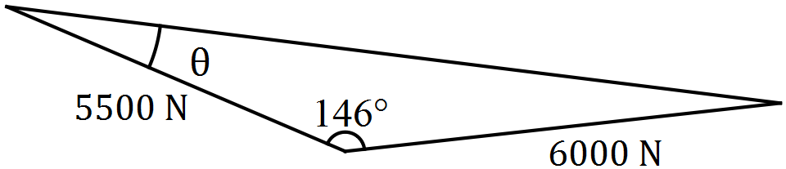

$$R^{2}={5500}^{2}+{6000}^{2}-2\left(5500\right)\left(6000\right)\cos{146} \\ R=10998.48≈11 000 \text{N}$$

$$\frac{6000}{\sin{θ}}=\frac{11000}{\sin{146}} \\ θ=17.76≈18°$$

Specific behaviours
sketch
uses cosine rule
shows magnitude before rounding
uses sine rule
determines angle

(b) The second tug boat is asked to decrease the magnitude of the force it applies to reduce the resultant force to 9 000 N. Determine the percentage decrease required. (3 marks)
Solution
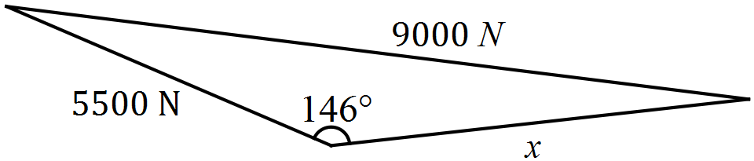

$${9000}^{2}={5500}^{2}+x^{2}-2\left(5500\right)\left(x\right)\cos{146} \\ x=3898$$

$$\frac{6000-3898}{6000}×100=35\% \text{reduction}$$

Specific behaviours
uses cosine rule
solves for magnitude
determines % reduction

Question 10 (8 marks)

(a) The points P and Q have position vectors 5i$-$2j and $-$4i$+$5j respectively.
The point K is such that PK = $-$4QK. Find the position vector of K. (3 marks)
Solution
PK=$-$4QK $⇒$ PK = 4KQ
Hence OK$-$(5i$-$2j)=4[($-$4i+5j)$–$OK
5 OK=$-$11i+18j
OK =$\frac{1}{5}$($-$11i+18j)

Specific behaviours
reverses vector to remove the $-$4
sets up vector equation
correct answer

(b) Given that $u=〈 -4,16 〉$ and $\left|v\right|=100,$ find $v$ if $u+v$ is to be in the same direction as vector $〈 2,2 〉$. (5 marks)

Solution
$〈-4,16〉+v=⇒λ〈2,2〉$
$$v=λ〈2,2〉-〈-4,16〉$$
$v=〈2λ+4, 2λ-16〉$
Since $\left|v\right|=100$, $\sqrt{{\left(2λ+4\right)}^{2}+{\left(2λ-16\right)}^{2 }}=100$
Using the classpad $λ=-32, 38$
But, $λ>0$ hence $λ=38$
$v=〈80, 60〉$

Question 11 (8 marks)
(a) In the diagram, $A$ , $B$, $C$ and $D$ lie on the circumference of circle with centre $O$. Given that $∠ADC=67°$, $∠BCO=63°$ and $∠DCO=23°$ determine the values of $a$, $b$ and $c$. (3 marks)

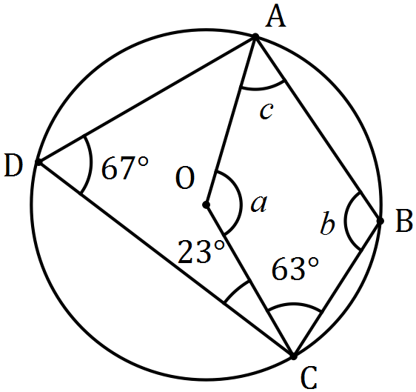
Solution
$$a=2×67=134° \\ b=180-67=113° \\ c=360-63-113-134=50°$$

Specific behaviours
$a$
$b$
$c$

(b) In the diagram below, points $B$, $C$ and $D$ lie on the circumference of circle centre $O$ and $AB$ and $AD$ are tangents to the circle.
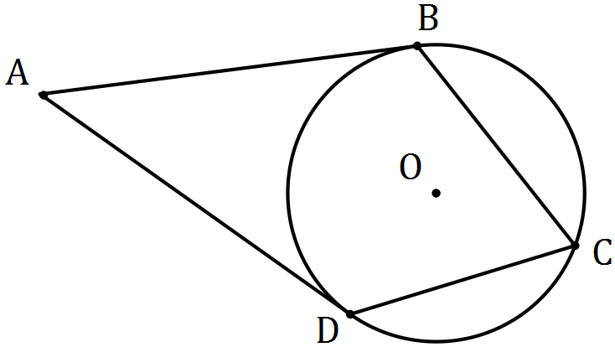

(i) Prove that $ABOD$ is a cyclic quadrilateral. (3 marks)
Solution
$∠ABO=∠ADO=90°$ (tangent-radii angle).
Hence $∠ABO+∠ADO=180°$.
Hence $ABOD$ is a cyclic quadrilateral, as opposite angles $∠ABO$ and $∠ABO$ are supplementary.

Specific behaviours
indicates tangent-radii are at 90°
indicates opposite pair of angles are supplementary
writes conclusion

(ii) Determine the size of $∠BAD$ if the size of $∠BCD=78°$. (2 marks)
Solution
$$∠BOD=2×78=156°$$
$$∠BAD=180-156=24°$$

Specific behaviours
determines $∠BOD$
determines $∠BAD$

Question 12 (8 marks)
A seaplane with a cruising speed of 250 kmh⁻¹ is required to fly to a location 355 km away on a bearing of 305°. A wind of 36 kmh⁻¹ is blowing from bearing 020°.

(a) Sketch a diagram to show this information. (2 marks)
Solution
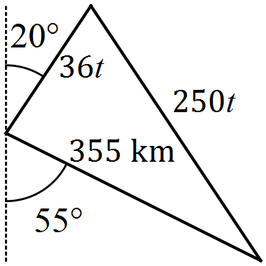

Specific behaviours
includes required path
includes bearings or 105° angle in triangle

(b) Determine the bearing that the seaplane should steer. (3 marks)
Solution
$$\frac{250t}{\sin{105}}=\frac{36t}{\sin{θ}}$$

$$θ=8.00°$$

$$\text{Bearing is} 305+8=313°$$

Specific behaviours
uses sine rule
solves triangle
states bearing

(c) Determine the flight time, in hours and minutes. (3 marks)
Solution
$$\frac{250t}{\sin{105}}=\frac{355}{sin⁡(180-105-8)}=\frac{355}{\sin{67}}$$

$$t=1.49 \text{h}$$

$$0.49×60=29.4$$
$$t=1 \text{h} 29 \text{m}$$

Specific behaviours
uses sin or cosine rule
determines $t$
states $t$ in h:m

Question 13 (9 marks)
Seven teams from WA, six teams from SA and five teams from NT apply for eight available places in a league competition. The league is run so that every team plays every other team exactly once and no game ends in a tie.

(a) The organisers decide that there must be at least four teams from WA and an equal number of teams from SA and NT. Determine the total number of ways in which the organisers can select the eight teams for the league. (3 marks)
Solution
$$n=\left(\begin{matrix}7 \\ 4\end{matrix}\right)×\left(\begin{matrix}6 \\ 2\end{matrix}\right)×\left(\begin{matrix}5 \\ 2\end{matrix}\right)+\left(\begin{matrix}7 \\ 6\end{matrix}\right)×\left(\begin{matrix}6 \\ 1\end{matrix}\right)×\left(\begin{matrix}5 \\ 1\end{matrix}\right)$$

$$n=5250+210=5460 \text{ways}$$

Specific behaviours
identifies ways to select teams using combinations
shows use of multiplication and addition
calculates correct number

Assume the eight teams have already been chosen.

(b) Determine the number of games that will be played in the league and hence the number of schedules possible for the first three games. (3 marks)
Solution
$${}_{ }^{8}{C_{2}}=28 \text{games required}$$

$${}_{ }^{28}{P_{3}}=19656 \text{ways}$$

Specific behaviours
calculates games required
uses permutation to arrange
evaluates number of ways

(c) Use the pigeon hole principle to show that if no team loses all its games, then at least two teams finish the competition with the same number of wins. (3 marks)
Solution
There are 7 pigeonholes, labelled with the number of possible wins for each team: {1, 2, 3, 4, 5, 6, 7} - no team loses all games and each team plays 7 others.

But there are 8 numbers to go into these pigeonholes (the number of wins by each of the 8 teams).

So at least one of the pigeonholes must contain two numbers, and so at least two teams must finish the competition with the same number of wins.

Specific behaviours
identifies pigeonholes
identifies pigeons
explains result

Question 14 (8 marks)
Three vectors are given by $a=3i-4j$, $b=-3i+1.5j$ and $c=-2i+yj$, where $y$ is a constant.

(a) Determine the vector projection of $b$ on $a$. (3 marks)
Solution
$$\hat{a}=\frac{3}{5}i-\frac{4}{5}j$$

$$b∙\hat{a}=-3$$

$$\left(b∙\hat{a}\right)×\hat{a}=-\frac{9}{5}i+\frac{12}{5}j$$

Specific behaviours
states unit vector for $a$
states $b∙\hat{a}$
states projection as vector

(b) Determine the value(s) of $y$ if

(i) $a$ and $c$ are perpendicular. (2 marks)
Solution
$$a∙c=0⇒-6-4y=0$$
$$y=-\frac{3}{2}$$

Specific behaviours
uses scalar product
states value of $y$

(ii) the angle between the directions of $b$ and $c$ is 45°. (3 marks)

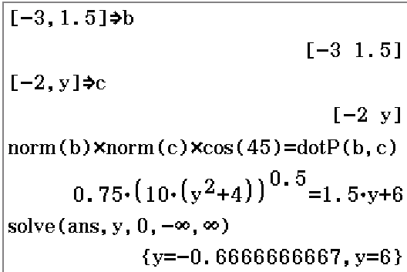
Solution
$$\cos\left(45\right)=\frac{\left(-3i+1.5j\right)∙(-2i+yj)}{|-3i+1.5j|×|-2i+yj|}$$

$$y=-\frac{2}{3}, y=6 (\text{using CAS})$$

Specific behaviours
uses scalar product
states one solution
states second solution
(CAS is quickest if use numerical solve as shown)

Question 15 (9 marks)
(a) The work done, in joules, by a force of $F$ Newtons in changing the displacement of an object by $s$ metres, is given by the scalar product of $F$ and $s$.

(i) A force of 250 N acting due south moves an object 4.3 m in a south-westerly direction. Determine the work done. (2 marks)
Solution
$$wd=250×4.3×\cos{45} \\ =760 \text{N}$$

Specific behaviours
substitutes correctly
evaluates work done

(ii) Another force of 155 N does 269 joules of work in moving an object 190 cm. Determine the angle between the force and the direction of movement. (2 marks)
Solution
$$269=155×1.9×\cos{θ} \\ θ=24°$$

Specific behaviours
substitutes correctly
evaluates angle

(b) A triangle is formed by three non-zero vectors $a$, $b$ and $c$, so that $c=a-b$, and $θ$ is the angle between $a$ and $b$.
Solution
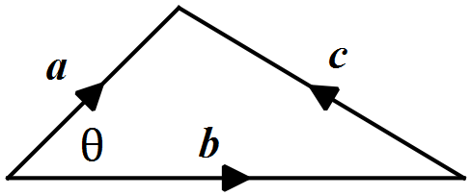

Specific behaviours
sketch

(i) Sketch the triangle. (1 mark)

(ii) Explain why $c∙c={\left|c\right|}^{2}$. (1 mark)
Solution
using definition of scalar product, since $θ=0$ and $\cos{0}=1$, then $c∙c={\left|c\right|}^{2}$.

Specific behaviours
explanation

(iii) Use $c∙c=\left(a-b\right)∙\left(a-b\right)$ to deduce the cosine rule. (3 marks)
Solution
$$c∙c=\left(a-b\right)∙\left(a-b\right) \\ c∙c=a∙a-a∙b-b∙a+b∙b \\ {\left|c\right|}^{2}={\left|a\right|}^{2}+{\left|b\right|}^{2}-2\left|a\right|\left|b\right|\cos{θ}$$

Specific behaviours
expands scalar product
uses result from (ii)
uses scalar product definition

Question 16 (10 marks)
In the diagram below, $POT$ is a diameter of circle with centre $O$, $QP$ is a tangent to the circle at $P$, $QR$ is a tangent to the circle at $R$ and $PT$ is extended to meet $QR$ extended at $S$. You may want to let $∠OTR=θ$.

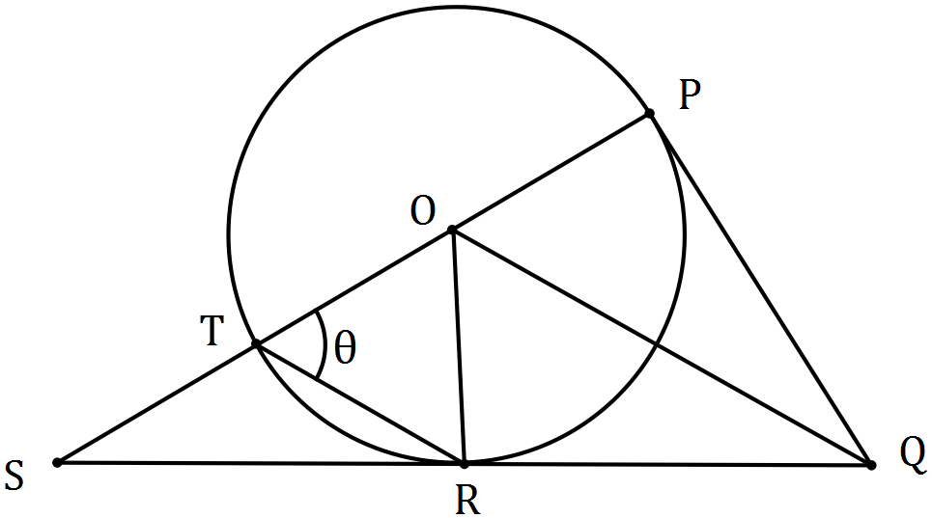

(a) Prove that $ΔOPQ$ is congruent to $ΔORQ$. (3 marks)
Solution
(i) $OP=OR$ (radii)
(ii) $QP=QR$ (tangent length from external point)
(iii) $OQ$ (common to both triangles)
(iv) $∠OPQ=∠ORQ$ (tangent-radius angle 90°)

Using various combinations, reason one of SSS, SAS or RHS.

Specific behaviours
first statement with reason
second and third statements with reasons
relevant conclusion

(b) Prove that $OQ$ is parallel to $TR$. (4 marks)
Solution (one of many possibilities)
Given $∠OTR=θ$, then $∠ORT=θ$ (as $ΔOTR$ isosceles - $OT$ and $OR$ radii)
Hence $∠POR=2θ$ (sum of interior angles $=$ opposite exterior angle)
Hence $∠POQ=θ$ (congruent triangles, $∠POQ=∠ROQ$)
Hence $∠OTR=∠POQ$ (corresponding angles equal)
Hence $OQ$ is parallel to $TR$

Specific behaviours
uses isosceles triangle
determines $∠POR$
determines $∠POQ$
uses corresponding angles to make conclusion

(c) If $TR=TS$, deduce that $ΔOTR$ is equilateral. (3 marks)

Solution
$ΔTSR$ is isosceles.
Hence $∠TSR=∠TRS=\frac{θ}{2}$ (sum of interior angles $=$ opposite exterior angle)
But $∠TRS=90-∠ORT=90-θ$ (tangent-radius angle 90°)
Hence $90-θ=\frac{θ}{2}⇒θ=60°$.
Hence $∠OTR=∠ORT=∠TOR=60°$ - $ΔOTR$ is equilateral.

Specific behaviours
expresses $∠TRS$ using isosceles triangle
expresses $∠TRS$ using radii-tangent angle
solves for $θ$ and deduces triangle is equilateral

Question 17 (11 marks)
A small boat that can maintain a steady speed of 5 ms⁻¹ is to cross a river from $A$ to $B$, where $\vec{AB}=\left(35i-105j\right) \text{m}$.

A current of $\left(-i-2j\right) {\text{ms}}^{-1}$ flows in the river.

The velocity vector that the pilot of the small boat must set to travel from $A$ to $B$ is $ai+bj$, where $a$ and $b$ are constants.

(a) Explain why $t\left(a-1\right)=35$ and $t\left(b-2\right)=-105$, where $t$ is a constant. (3 marks)
Solution
The sum of the velocities of the boat and the river must be parallel to $AB$:
$$t\left(\left(ai+bj\right)+\left(-i-2j\right)\right)=\left(35i-105j\right)$$

The two given equations arise by equating $i$ and then $j$ coefficients from this equation.
Specific behaviours
uses sum of velocities
uses equation for parallel condition
equates individual coefficients

(b) Eliminate $t$ from the equations in (a) and hence express $b$ in terms of $a$, simplifying your expression. (3 marks)
Solution
$$t=\frac{35}{a-1}=\frac{-105}{b-2}$$

$$b-2=-\frac{105}{35}\left(a-1\right)$$

$$b=5-3a$$

Specific behaviours
equates both to t
cross-multiplies
simplifies

(c) Explain why $a^{2}+b^{2}=25$. (1 mark)

Solution
The magnitude of $ai+bj$ is the speed of the boat.

Specific behaviours
uses magnitude and speed

(d) Use your equations from (b) and (c) to determine the values of $a$ and $b$. (3 marks)
Solution
$$a^{2}+{\left(5-3a\right)}^{2}=25$$
$$a=0, 3$$
$$b=5, -4$$
$$v=3i-4j$$

Specific behaviours
writes equation
solves for $a$ and $b$
eliminates alternative solution

(e) Determine the time that the small boat will take to travel from $A$ to $B$. (1 mark)
Solution
$$t=\frac{35}{a-1}=\frac{35}{2}=17.5 \text{s}$$

Specific behaviours
states time

Question 18 (6 marks)
Let $g\left(x\right)=x^{2}-8x+19, x∈Z$.

(a) Use an example to show that when $x$ is odd, $g\left(x\right)$ is even. (1 mark)
Solution
$$\text{If} x=1 \text{(odd)} \text{then} g\left(1\right)=1-8+19=12 (\text{even)}$$

Specific behaviours
suitable example

(b) Write the contrapositive of "if $g(x)$ is an even integer, then $x$ is an odd integer". (1 mark)
Solution
If $x$ is not odd, then $g(x)$ is not even.

Specific behaviours
writes contrapositive

Any even integer $m$ can be expressed in the form $m=2a$, where $a∈Z$. Similarly, any odd integer $n$ can be expressed in the form $n=2a+1$.

(c) Simplify $g(2a)$. (1 mark)
Solution
$$g\left(2a\right)={\left(2a\right)}^{2}-8\left(2a\right)+19=4a^{2}-16a+19$$

Specific behaviours
substitutes and simplifies

(d) Express $g(2a)$ in a form that clearly shows it is an odd integer. (1 mark)
Solution
$$g\left(2a\right)=2\left(2a^{2}-8a+9\right)+1$$

Specific behaviours
expresses in form $2n+1$

(e) Use your answers above to prove that if $g(x)$ is even, then $x$ is odd. (2 marks)
Solution
(c) and (d) prove that when $x$ is not odd (ie even) then $g(x)$ is not even (ie odd).

Hence the contrapositive statement from (b) is true and so the original statement that is to be proved must be true.

Specific behaviours
uses results from (c) and (d)
explains contrapositive is true and hence statement must be true

Additional working space

Question number: _________

Additional working space

Question number: _________

Additional working space

Question number: _________

© 2016 WA Exam Papers. Applecross Senior High School has a non-exclusive licence to copy and communicate this paper for non-commercial, educational use within the school. No other copying, communication or use is permitted without the express written permission of WA Exam Papers. SN002-091-4.

